Contents

1. Deployment 1

1.1. Pre-deployment steps 1

1.1.1. CRM Solution Deployment 2

1.1.2. Data Migration Process 2

1.2. Post-Deployment Steps 3

1.2.1. Remove/Delete Records 3

1.2.2. Update Records 3

1.2.3. Modify System Users 4

1.2.4. Verify Records Imported Successfully 4

# Deployment

## Pre-deployment steps

**NOTE:** user must be logged in as an System Administrator to deploy the solution and a Global Admin to enable mailbox modifications. One can check their roles by clicking on Users:

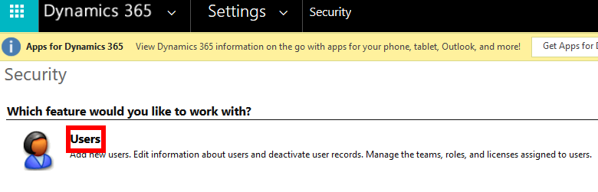

Verify assets:

* + - SmallBusinessStarterPack_1_0_0_0
    - RefreshedConnectionsUI_1_1_managed
    - SharePointFormView_1_1_0_0_managed
    - SparkleXRM_7_2_7_managed
    - KraftwareAutoNumber_1_2_0_0_managed

Gather the required solutions and Starter Pack into a folder to make installation simpler, we will need them in a bit. In total we should have five solutions: 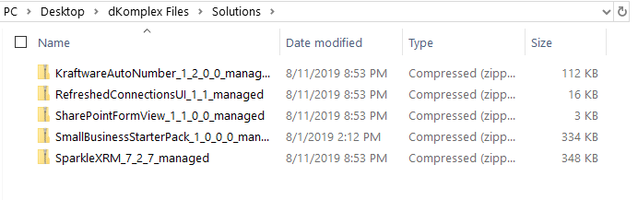

### CRM Solution Deployment

### Data Migration Process

#### Exporting

#### Importing

Updated Components:

* + 1. CRUD the folllowing after installation to fit needs:
       1. Security Roles, Processes, Forms, Dashboards
    2. Log in to your desired Dynamics CRM Environment you want the solution installed
    3. Head over to Settings > click ‘Solutions’. Most SiteMaps should have the Settings located here. If using the Unified Interface go to step iv.

1. 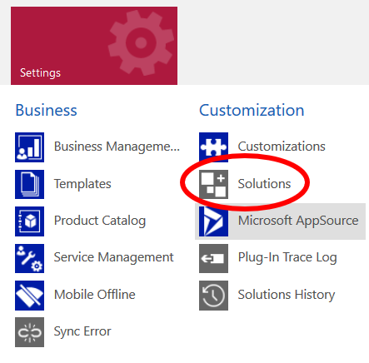
   * 1. If you are using the Unified Interface, go to the right and click the gear icon and open ‘Advanced Settings’ > Solutions.
2. 
3. **NOTE**: The first four solutions **MUST** be imported before importing the SmallBusinessStarterPack.
4. 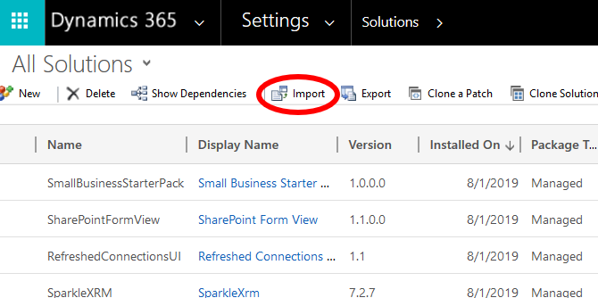
   * 1. Import RefreshedConnectionsUI_1_1_managed
        1. Select Import
        2. Choose the file named: RefreshedConnectionsUI_1_1_managed
        3. Verify solution information on next screen then click import
     2. Import SharePointFormView_1_1_0_0_managed
        1. Select Import
        2. Choose the file named: SharePointFormView_1_1_0_0_managed
        3. Verify solution information on next screen then click import
     3. Import SparkleXRM_7_2_7_managed
        1. Select Import
        2. Choose the file named: SparkleXRM_7_2_7_managed
        3. Verify solution information on next screen then click import
     4. Import KraftwareAutoNumber_1_2_0_0_managed
        1. Select Import
        2. Choose the file named: KraftwareAutoNumber_1_2_0_0_managed
        3. Verify solution information on next screen then click import
     5. Import SmallBusinessStarterPack_1_0_0_0
        1. Select Import
        2. Choose the file named: SmallBusinessStarterPack_1_0_0_0
        3. Verify solution information on next screen then click import

## Post-Deployment Steps

### Remove/Delete Records

### Update Records

### Update Inactive Processes

* + 1. Update: Opportunity - New Opportunity Entered Notification to Owner
       1. Navigate to Settings > Solutions > SmallBusinessStarterPack
       2. Open process

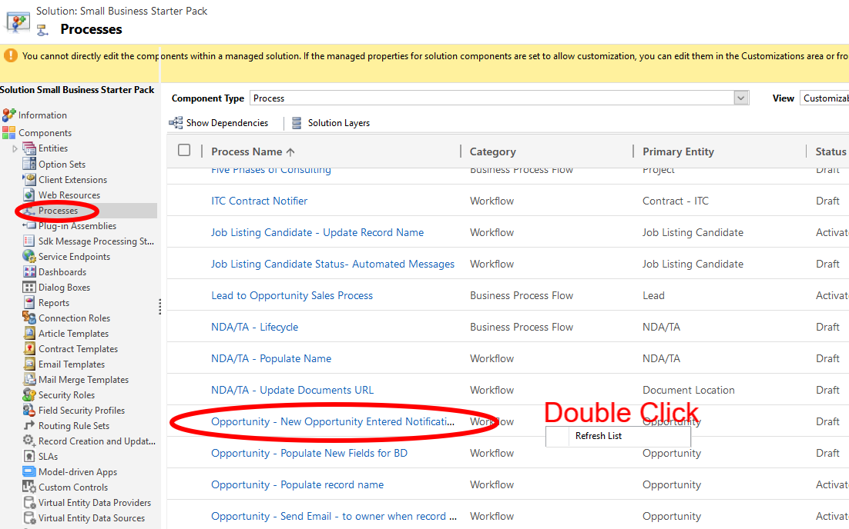

* + - 1. Open email, click Set Properties
      2. Remove and replace From field with an active user account that you want to send the email

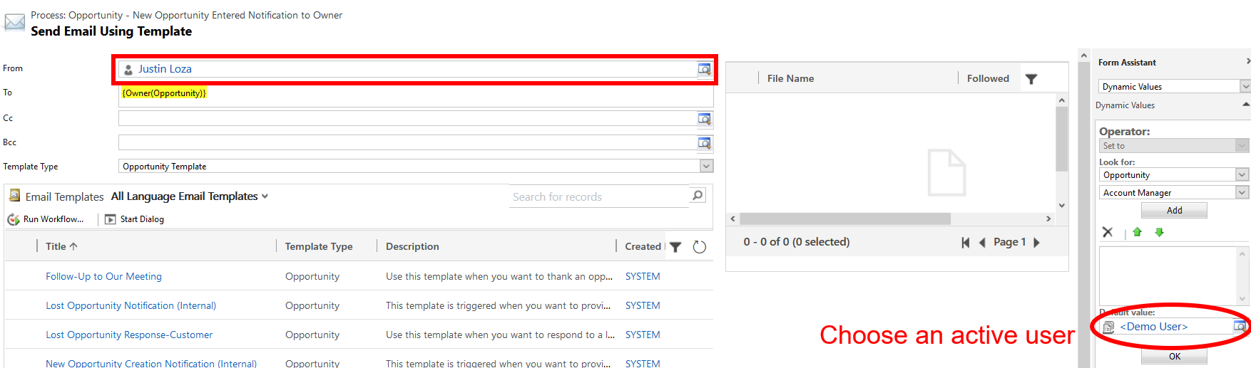

* + - 1. Click Save and Close
      2. Click Activate on the Process
    1. Update: Opportunity - Populate New Fields for BD
       1. Navigate to Settings > Solutions > SmallBusinessStarterPack
       2. Open process
       3. Click Activate at the top

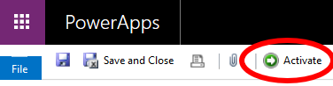

* + - 1. Click Save and Close
    1. Update: Opportunity – Send email to owner when record is updated
       1. Navigate to Settings > Solutions > SmallBusinessStarterPack
       2. Open process
       3. Open email, click Set Properties
       4. Remove and replace From field with an active user account that you want to send the email. Similar to the first process we updated
       5. Click Save and Close
       6. Click Activate on the Process

### Update SiteMap (Optional)

* + - * Navigate to Solutions > SmallBusinessStarterPack
      * Client Extensions > Site Map

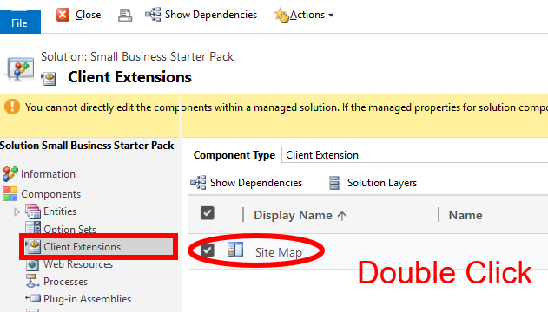

* + - * Modify as needed
      * Click ‘Save and Close’

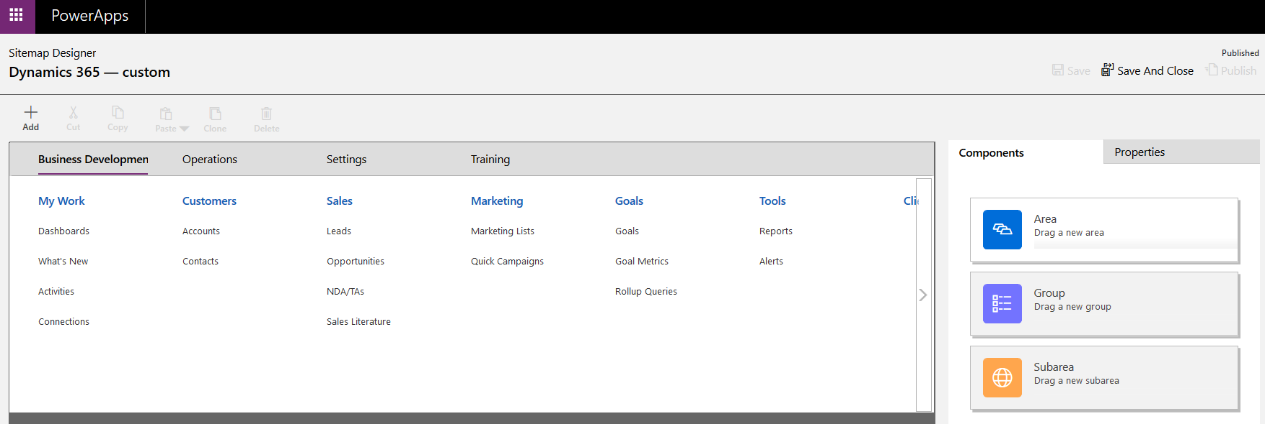

### Modify System Users

#### Assign Business Units

#### Assign Security Role

### Verify Records Imported Successfully

